Use-Case-Realization Specification: Payment

Version 1.0

Revision History

|  |  |  |  |
| --- | --- | --- | --- |
| **Date** | **Version** | **Description** | **Author** |
| 12/12/2019 | 1.0 | details | Tran Van Dat |
|  |  |  |  |
|  |  |  |  |
|  |  |  |  |

Table of Contents

1. Introduction 2

1.1 Purpose 2

1.2 Scope 2

1.3 Definitions, Acronyms, and Abbreviations 2

1.4 References 2

1.5 Overview 2

2. Flow of Events—Design 2

3. Derived Requirements 2

Use-Case-Realization Specification: Payment

# Introduction

## Purpose

This document describes how the Payment Use-Case is realized within the design model, in terms of collaborating objects.

## Scope

This document applies to the Computer Shop System which will be developed by our group.

## Definitions, Acronyms, and Abbreviations

None

## References

None

## Overview

In the following section, Use-Case Realization Specification of the Payment Use-Case of the Computer Shop System is provided in detail. The first section includes class diagrams with relationships that participate in the realization of the use case. The second section contains diagrams sequence describing how the use case is realized in terms of collaborating objects

# Flow of Events—Design

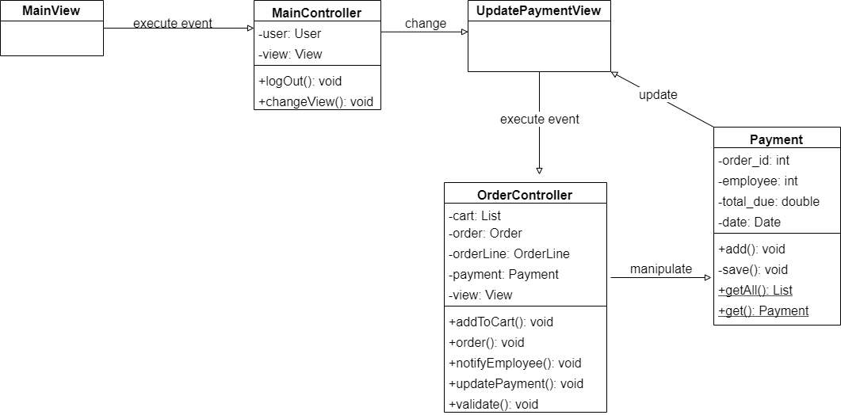

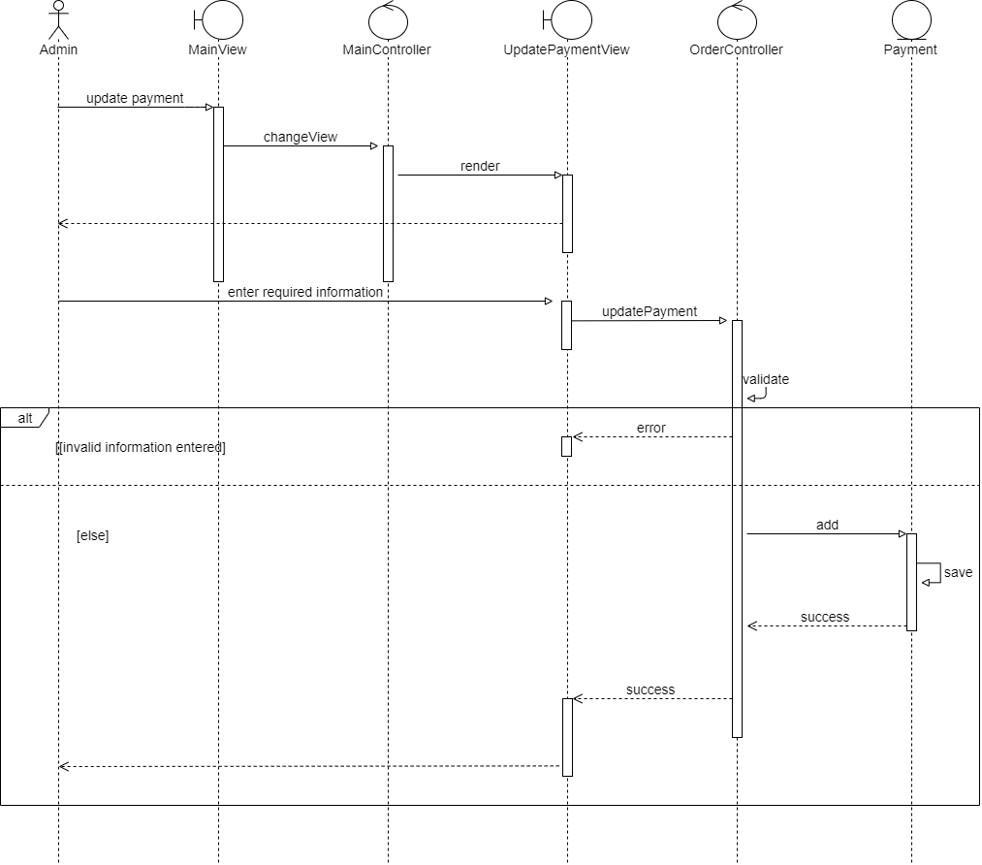

# Derived Requirements

None